

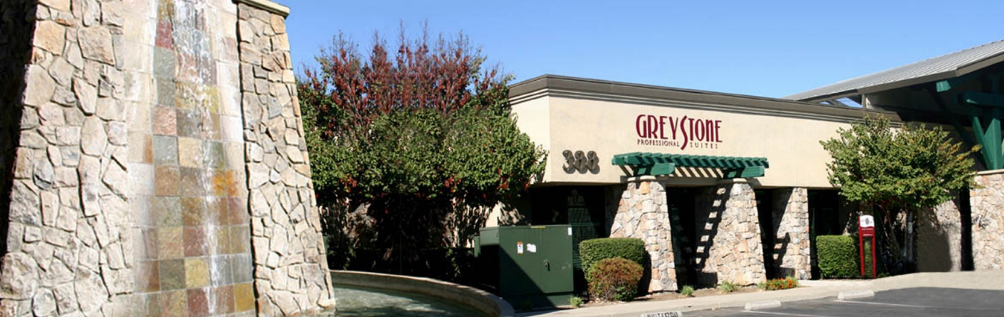

**Professional Medical & Business Offices**

**360-388 E Yosemite Ave, Merced, CA 95340**

www.hmgt.com

Suite 100

374 E. Yosemite Ave

1,862 useable s.f. + 143 CAM s.f = 2,005

**Details**

* **Shared Reception/Waiting Area**
* **5 Spacious Offices**
* **Month-to-Month Leases**
* **Workstations**
* **Common Area Restrooms**
* **24 Hour Access**

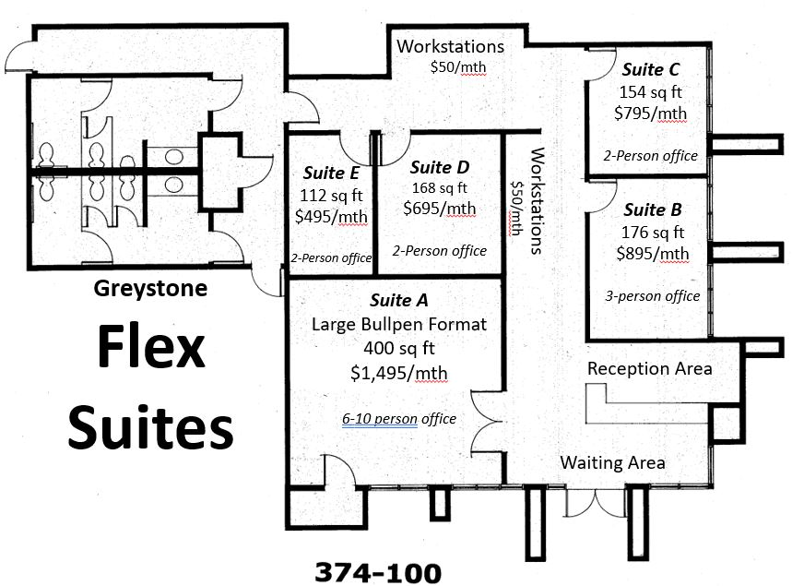

Contact Us:

Greystone Business Park

Building E – 374 E. Yosemite Avenue

Michelle Esquibias

(209) 383-2244 ext. 129

michellee@hmgt.com

Heritage Management Group

755 E. Yosemite Ave, Suite J

Merced, CA 95340

(209) 383-2244