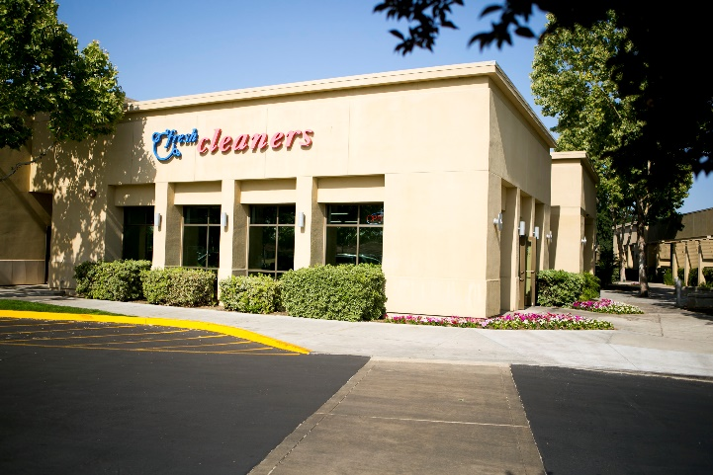

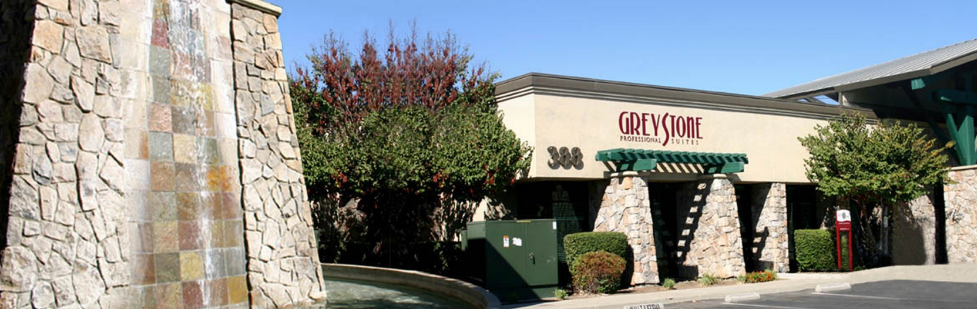

**Retail & Business Offices**

www.hmgt.com

Details

Available Space

755 E. Yosemite Ave. Ste. L, Merced, CA 95340

**About Property**

**The Promenade is the premiere shopping and dining destination in North Merced, a growing community in need of restaurants and retail services. The Promenade has been providing excellent dining and retail experience to the Merced area since 2005 and we look forward to servicing your business needs in our beautiful community.**

**The Promenade is located at the corner of Paulson Rd and Yosemite Ave, in close proximity to UC Merced, Merced College, and Mercy Hospital.**

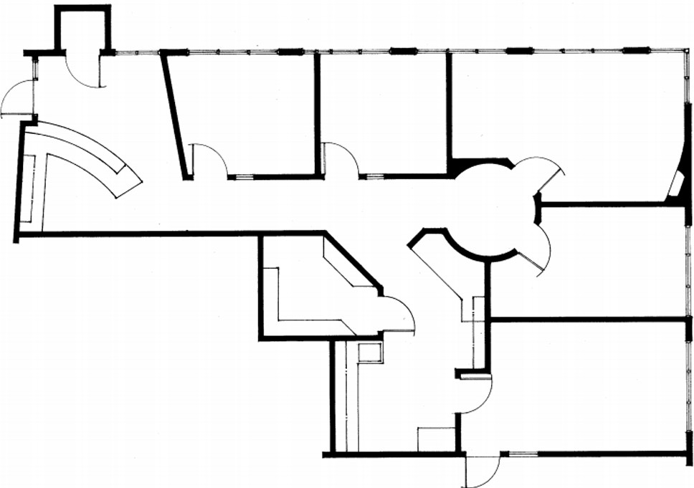

Contact Us:

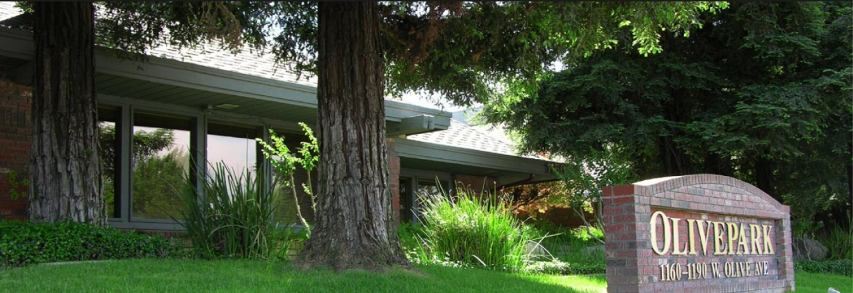

755 E. Yosemite Ave. Ste. L

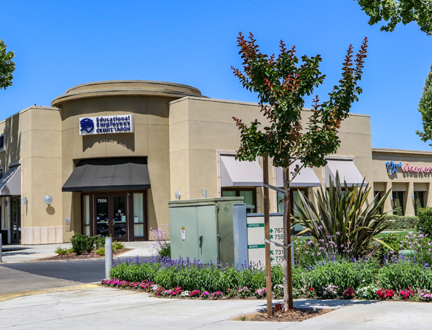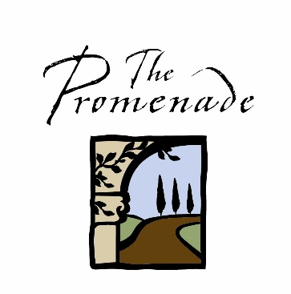

2,006 square feet

$2.00 per s.f. + $0.57 per s.f. CAM Charges Monthly

Michelle Esquibias

(209) 383-2244 ext. 129

[michellee@hmgt.com](mailto:michellee@hmgt.com)

Heritage Management Group

755 E. Yosemite Ave, Suite J

Merced, CA 95340

(209) 383-2244